06.06.2008
Name :
Number :
CEM 123 DIGITAL LOGIC MAKE UP EXAM QUESTIONS

( 30 ) |  | For the following state diagram, find the corresponding ASM chart and state table. What is the type ?  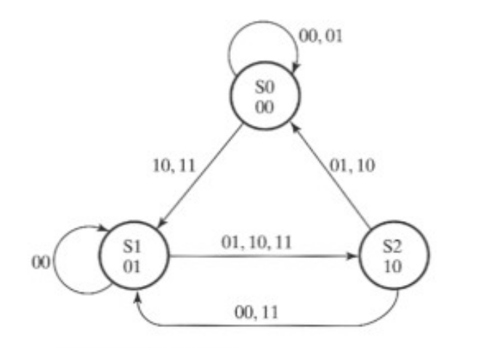
(40) |  | Design a synchronous counter  If the input x=1 the counter sequence: 2, 3, 4, 7, 1  If the x=0 the counter sequence : 7 5 1 3 6  - Design the counter using JK flip flops  - Test the circuit whether it counts correctly.  - Determine the behavior of the circuit in the case of entering unused states.  - Draw Algorithmic State Chart  - Draw state diagram
(10) |  | Draw 3-bits asynchronous down counter. If we need 6 bits one what is the simple circuit?
(10) |  | Give the differences between EEPROM and RAM. Which of them is better? Why?
(10) |  | A memory has 10 data (input/output) lines and 12 address lines. What is the bit storage capacity?

